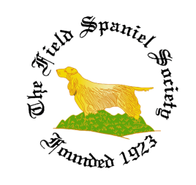
FIELD SPANIEL SOCIETY 2023 ORDER FORM
Orders are now being taken for the new range of clothing 2023 to mark the Centenary year.
All items will be embroidered with the new Centenary Logo
Gillets £28 Hoodies £25, Sweat shirts £25 Fleece Jackets £25 and Polo Shirts £15
These can either be collected at a show or posted out at cost (£3.50 UK)
Colours: Bottle Green, Navy or Maroon.
Sizes: XS, S, M, LGE, XL, 2XL, 3XL, 4XL. (Size Guidelines: M approx. size 12, XL approx. size 16)
Description | Size | Colour | Quantity | Price
Gillett
£28
Hoodie
£25
Sweat shirt
£25
Fleece Jacket
£25
Polo Shirt
£15
Total Excl. Delivery
Orders can only be taken for prepaid items.
Payment can be made directly into the Society account, contact the Secretary for details

Please Post/Collect at: …………………………………………………………………………….……………………………………….
Delete as required
Name: ……………………………………………………….
Address: ……………………………………………………….
……………………………………………………….
Post Code: ……………………………………………………….
Tel. No: ……………………………………………………….
Email: ……………………………………………………….
Completed order forms should be returned to the Sec at: secretary@fieldspanielsociety.co.uk

